Project Name
Software Requirements & Specifications

Instructions: Replace template descriptions [in italic blue] with the corresponding section content.

Team 1
John Doe
Jane Doe

Contents
Contents 2
Introduction 3
Overall description 4
Product perspective 5
Product functions 5
User characteristics 6
Constraints 6
Assumptions and dependencies 6
FUNCTIONAL Requirements 7
USER REQUIREMENTS 7
Registration 7
Login 8
Change Password 8
System Requirements 9
Registration 9
Login 10
Change Password 11
System Models 12
Registration 12
Login 13
Change Password 15
Domain Analysis 17
NON-functional requirements 18
Appendix 20
Index 20

Introduction
The introduction of the SRS should provide an overview of the entire SRS. It should contain the following
Subsections:
- Purpose;
- Scope;
- Definitions, acronyms, and abbreviations;
- References;
- Overview.
This section should describe the need for the system. It should briefly describe the system’s functions and explain how it will work with other systems. It should also describe how the system fits into the overall business or strategic objectives of the organization commissioning the software.
General Description of the system. Explanation of ’how’ the system will fit within the business objectives
Guidelines:
- Purpose: Describe a current problem that your organization is experiencing, or the problem you are trying to solve. For example, “all paperwork is done manually and it takes too long”
  - Describe the goal(s) of the software. Goals are broad in nature and identify what your team is aiming to solve.
  - Describe the objectives for the software that will be used to meet the previously identified goals. Objectives are more concrete and should be verifiable. For example, if your goal is “i.e., improve the processing of new claims”, your objectives could be “reduce the time that it takes to process a new claim by 50%”.
- Scope: Define and describe the scope of the project. What is included and what is left out of this version.
  - Identify the software product(s) to be produced by name (e.g., Host DBMS, Report Generator, etc.)
  - Explain what the software product(s) will, and, if necessary, will not do;
  - Describe the application of the software being specified, including relevant benefits, objectives, and goals;
  - Be consistent with similar statements in higher-level specifications (e.g., the system requirements specification), if they exist
- Definitions, acronyms and abbreviations: This subsection should provide the definitions of all terms, acronyms, and abbreviations required to properly interpret the SRS. This information may be provided by reference to one or more appendixes in the SRS or by reference to other documents.
- References: This subsection should
  - Provide a complete list of all documents referenced elsewhere in the SRS;
  - Identify each document by title, report number (if applicable), date, and publishing organization;
  - Specify the sources from which the references can be obtained.
- Overview:
  - Describe what the rest of the SRS contains;
  - Explain how the SRS is organized.

Overall description
This section of the SRS should describe the general factors that affect the product and its requirements. This section does not state specific requirements. Instead, it provides a background for those requirements, which are defined in detail in Section 3 of the SRS, and makes them easier to understand.
This section usually consists of six subsections, as follows:
- Product perspective;
- Product functions;
- User characteristics;
- Constraints;
- Assumptions and dependencies;
- Apportioning of requirements.

Product perspective
This subsection of the SRS should put the product into perspective with other related products. If the product is independent and totally self-contained, it should be so stated here. If the SRS defines a product that is a component of a larger system, as frequently occurs, then this subsection should relate the requirements of that larger system to functionality of the software and should identify interfaces between that system and the software.
A block diagram showing the major components of the larger system, interconnections, and external interfaces can be helpful.
This subsection should also describe how the software operates inside various constraints. For example, these constraints could include
- System interfaces: These
- User interfaces;
- Hardware interfaces;
- Software interfaces;
- Communications interfaces;
- Memory;
- Operations;
- Site adaptation requirements.

For our project, we’ll just concentrate on the User Interfaces, but you can include any of the other subsections outlined above.

Product functions
This subsection of the SRS should provide a summary of the major functions that the software will perform. For example, an SRS for an accounting program may use this part to address customer account maintenance, customer statement, and invoice preparation without mentioning the vast amount of detail that each of those functions requires. Sometimes the function summary that is necessary for this part can be taken directly from the section of the higher-level specification (if one exists) that allocates particular functions to the software product. Note that for the sake of clarity
- The functions should be organized in a way that makes the list of functions understandable to the customer or to anyone else reading the document for the first time.
- Textual or graphical methods can be used to show the different functions and their relationships. Such a diagram is not intended to show a design of a product, but simply shows the logical relationships among variables.

User characteristics
This subsection of the SRS should describe those general characteristics of the intended users of the product including educational level, experience, and technical expertise. It should not be used to state specific requirements, but rather should provide the reasons why certain specific requirements are later specified in the User Requirements section.

Constraints
This subsection of the SRS should provide a general description of any other items that will limit the developer's options. For this section, simply chose a couple of them you believe might be relevant to your project and expand on them.
These include:
- Regulatory policies;
- Hardware limitations (e.g., signal timing requirements);
- Interfaces to other applications;
- Parallel operation;
- Audit functions;
- Control functions;
- Higher-order language requirements;
- Signal handshake protocols (e.g., XON-XOFF, ACK-NACK);
- Reliability requirements;
- Criticality of the application;
- Safety and security considerations.

Assumptions and dependencies
This subsection of the SRS should list each of the factors that affect the requirements stated in the SRS. These factors are not design constraints on the software but are, rather, any changes to them that can affect the requirements in the SRS. For example, an assumption may be that a specific operating system will be available on the hardware designated for the software product. If, in fact, the operating system is not available, the SRS would then have to change accordingly.

FUNCTIONAL Requirements

Here, you describe the services provided for the user. The non-functional system requirements should also be described in this section. This description may use natural language, diagrams, or other notations that are understandable to customers. Product and process standards that must be followed should be specified.
UML: Use Cases for each interaction (multiple interactions per diagram is accepted).
Example:

USER REQUIREMENTS
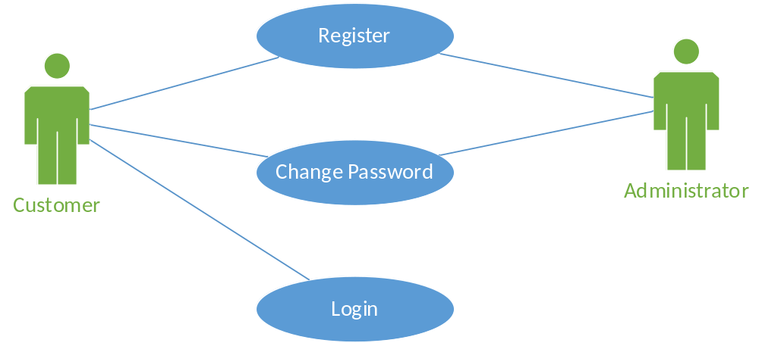

Registration
Any current customer should be able to self-register with the [YOUR SYSTEM NAME] as a Web user. The registration will allow the user to log in the system and access special features such as “submit/post data”, or “change personal data”. This operation is done only one time by the user (or the administrator). An administrator can register any customer using the same process. Only an administrator can register other administrator users. Customers cannot register any administrator type users.
The “registration” use case contains the following basic steps:
- [YOUR SYSTEM NAME] user fills in and submits data
- [YOUR SYSTEM NAME] System validates data
- [YOUR SYSTEM NAME] System creates user’s profile/account
- [YOUR SYSTEM NAME] System enables the activated account to log into the system

Login
Any registered user should be able to log into the [YOUR SYSTEM NAME] Web application. To successfully log into the system, the user must be already registered with the [YOUR SYSTEM NAME]. The login screen should be accessible from any place with access to the internet, and should work with all kind of browsers. After successfully authenticating, the user will be redirected to the home page and be granted access to any sections of the [YOUR SYSTEM NAME] Web app for his/her role. Both customers and administrators should use the same Login screen.
The “Login” use case contains the following basic steps:
- Registered user inputs credentials
- [YOUR SYSTEM NAME] System validates data against stored registered users
- If credentials match current user, then [YOUR SYSTEM NAME] System will grant access and redirect user to home page
- If credentials are incorrect, [YOUR SYSTEM NAME] System will return an error message to user for retry

Change Password
Any registered user should be able to access a page of the [YOUR SYSTEM NAME] Web app to change their current password for a new one. To be able to submit a password change, the user must also submit the current password. The new password should be input twice and both fields should match, to ensure the user typed the desired password. All password fields will be masked as to prevent any accidental discovery of the password while the registered user is using the Web app.
The “change password” use case contains the following basic steps:
- Logged in user access Change Password page
- User enters current password and new password, then submits the input
- [YOUR SYSTEM NAME] System validates current password
- [YOUR SYSTEM NAME] System validates new password meets security policy
- If current password is valid, then [YOUR SYSTEM NAME] System changes the password stored for the new one submitted
- If current password fails or the new password does not meet security policy rules, then an errors is sent back to the user to correct.

System Requirements
This should describe the functional and non-functional requirements in more detail. If necessary, further detail may also be added to the non-functional requirements. Interfaces to other systems may be defined.
Refined description of user requirements. Details of each Use Case with input and outputs.
Example:

Registration
The following table outlines the details of use case # 1: Registration
Use Case ID:1 | Registration
Description | There are two types of users who can register within the [YOUR SYSTEM NAME] Web site, customers and administrators. Customers must register to be allowed to navigate the site and post any desired transactions. Administrators are registered by other administrators and navigate the administrator view of the site.  To register with the system, a user must fill in a list of required fields before submitting the form. If the transaction is successful the user account will be created within the system.
Input | - First Name  - Last Name  - Email/Username  - Password
Output | If transaction was successful, then the system will return a Thank You message back to the user. If the transaction failed, the system will return the appropriate error message
Preconditions | The Email/Username does not exists within the system at the time the user submits the form.
Post Conditions | If succeeded, the user account will be created and stored within the system.
Action | [YOUR SYSTEM NAME] System will validate the following rules before creating the user account:  - All fields have values  - Username is unique within the system and does not exist at the time the user submits the registration  - Password meets the security policy rules

Login
The following table outlines the “Login” use case details:
Use Case ID:2 | Login
Description | A customer or an administrator will enter their correspondent credentials to get access granted to the site.  The system will present the same window to either type of user, and should recognize the user type once authentication is successful, to grant the user different access types based on the predefined role.
Input | Email and Password
Output | User should see the Home page upon successful login.
Pre-conditions | User has been previously registered successfully with the system. In addition, the user account must be active and should have not expired.
Post Conditions | User is redirected to the correspondent page based on the assigned role.
Action | The user submits the credentials (username/email and password). The system will verify that the user email already exists within the system, and will evaluate the posted password to see if it matches the one stored.

Change Password
The following table outlines the “Change Password” use case.
Use Case ID:3 | Change Password
Description | A user (customer or administrator) should be able to change their account password by providing the current credentials. Since the client browser does not show the values of the password input field, it is important that the system requires two values for the new password to ensure the user has typed the desired value.  In addition, the system will required the user’s current credentials to authenticate him or her before updating the account with the new specified password. If the username/email is already stored in memory, then the system will only require the user to specify the current password. If the system uses a “stateless” environment, it will require both username and current password for the authentication.
Input | Old password and new password. Optionally the username/email
Output | If the transaction succeeds, the system will send a “Success” message, but if the transaction fails, the system will send back an “error” message.
Pre-conditions | The user is already registered with the system, and his or her account is active.
Post Conditions | The submitted new password is stored within the system.  The user is shown a thank you message.
Frequency of Use | Many times a day

System Models
This might include graphical system models showing the relationships between the system components, the system, and its environment. Examples of possible models are object models, data-flow models, or semantic data models.
Activity diagrams, Sequence diagrams (at the component level), Static diagrams such as class diagrams with only the entity name and relationships (no attributes necessary). Data flow or State machine diagrams optional.
Minimum requirements for this section:
- One diagram (Activity, Sequence or State diagrams) per Use Case (approx. 3 per feature)
- One description per Use Case (approx. 3 per feature)

Registration
The diagram on the left describes the process that takes place as part of the registration transaction. The user access the registration page and fills out all required fields. Once the user submits the form, the system begins the processing by first validating each submitted input value.
If any of the fields contains invalid data or is a required field that was left blank, the transaction is aborted and the system returns an error message to the user. Once the user corrects the error and re-submits the process, the input values are once again validated until all fields are validated successfully.
At this point, the system will create and store the new user account within the system repository. If saving the data was successful, then the system will return a “welcome” or “thank you” message to the user.
The same process can be seen in the sequence diagram below. The proposed design defines a middle-tier component (Accounts) that will be responsible for all business rules and processing of the input data. The Web site component just routes all calls to the business logic layer, which in turn retrieves or posts data to the database layer.
The diagram also describes an alternative path for successful and failed transactions. If the transaction fails, then the user will receive a message outlining which input fields did not pass validation as to allow the user to correct the data and re-submit.
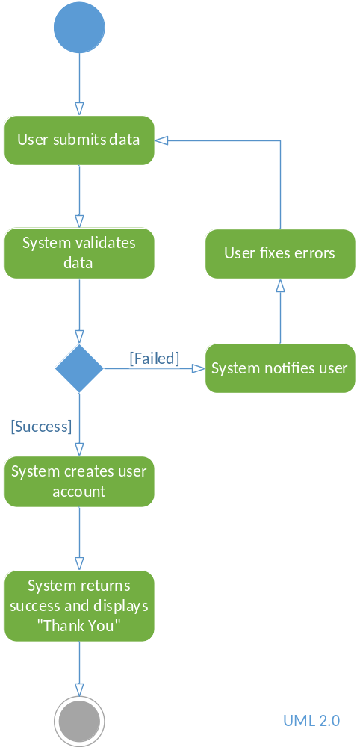

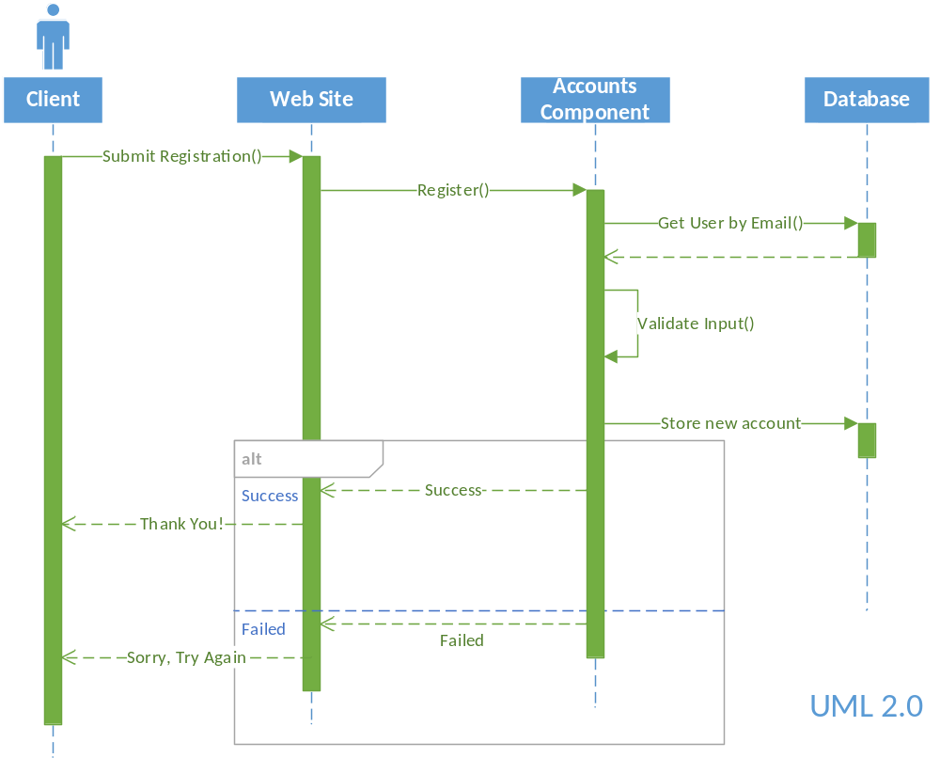

Login
The steps included in the Login transaction are described in the activity diagram below. The transaction begins with the user submitting his or hers username and password. Once the server receives the input, it validates that the username is already registered with the system. If no matching value is found, then the system will return an error message to the user to retype the credentials.
If the username is found in the system, then the stored password is retrieved and evaluated against the one submitted by the user. If both passwords match, then the user is granted access and a successful message is returned. If the passwords do not match, then the system will return an error message to correct the credentials and retry again.

The same process is outlines in the sequence diagram below. The Web Site component is responsible for receiving the user’s request, and route the message to the business logic layer or middle-tier. The business component in charge of processing the authentication is the Accounts component.
The Accounts component processes the request, access the data repository and evaluates any business rules required for the transaction. The first task is to retrieve the user account with a matching email/username from the request. If the account is found, the data layer will return a user account back to the Accounts component.
The system will then evaluate, if the account was found, that both passwords match. If so, the system will inform the Web Site component to grant access to the user. The Web Site component will then redirect the user to the appropriate page.
If the credentials did not pass validation, the system will return and error message to the user. This is depicted in the “alternative” flow of the sequence diagram below.
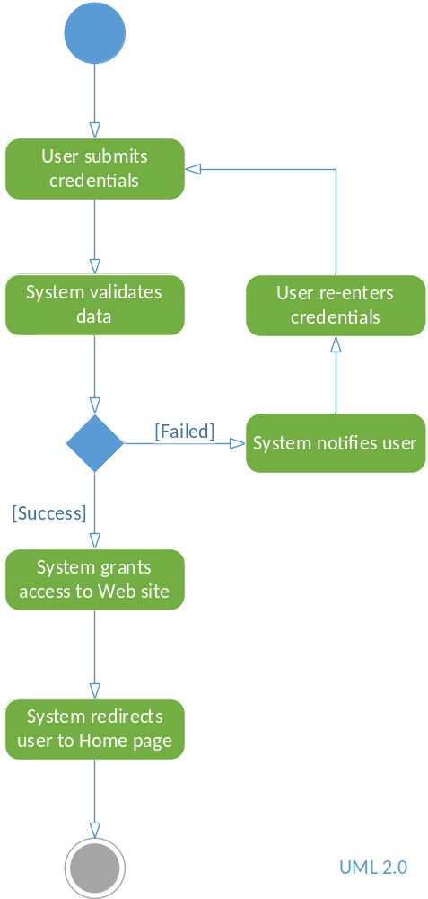

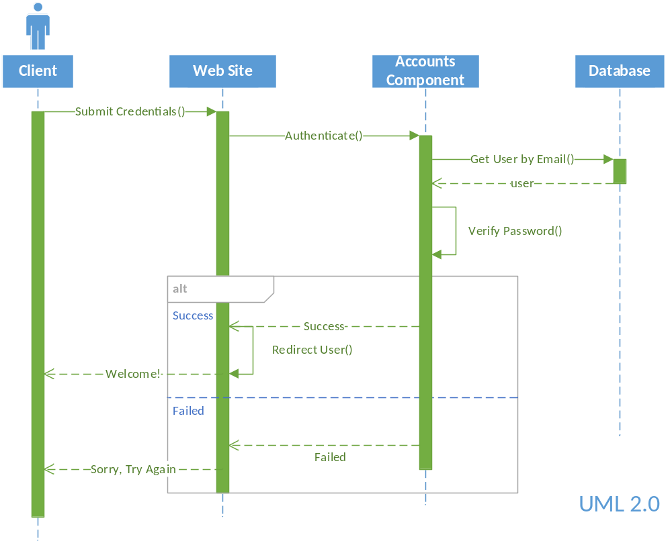

Change Password
To change the password, the user must submit the old credentials as well as the new ones. This is done to ensure that the user requesting a change of password is authentic. The activity diagram below shows the steps required to process the “change password” transaction.
The first step in the activity diagram represents the system receiving the input values from the user. If the system already has stored the username or email, then only the old password would be required. If the system does not have the current logged in username in memory, then both username/email and password will be required to authenticate the user before updating the account with the new password.
The system validates the user credentials and if they match, it proceeds to update the account with the new password. The new password will be submitted through two fields to ensure that the user has typed the desired value.
The sequence diagram shown below describes the responsibilities for each component. As shown, most of the work is done at the middle-tier layer. The Accounts component is responsible for evaluating the input values, querying the database and updating the user account.
The Web Site component is only in charge of routing the requests to the middle-tier component and returning a transaction result message back to the user.
Not shown in the diagram is the evaluation of both “new password values” entered by the user. This evaluation could be done at the client browser to provide faster feedback.
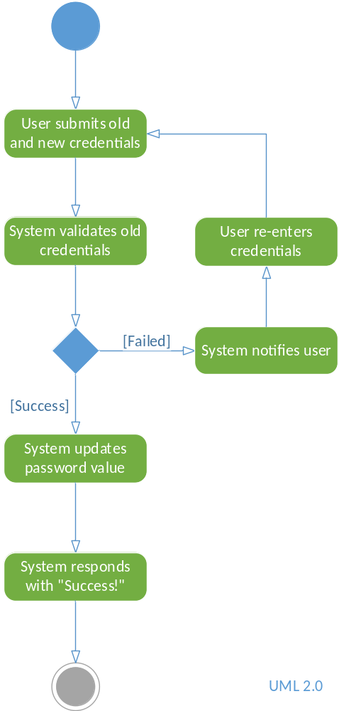

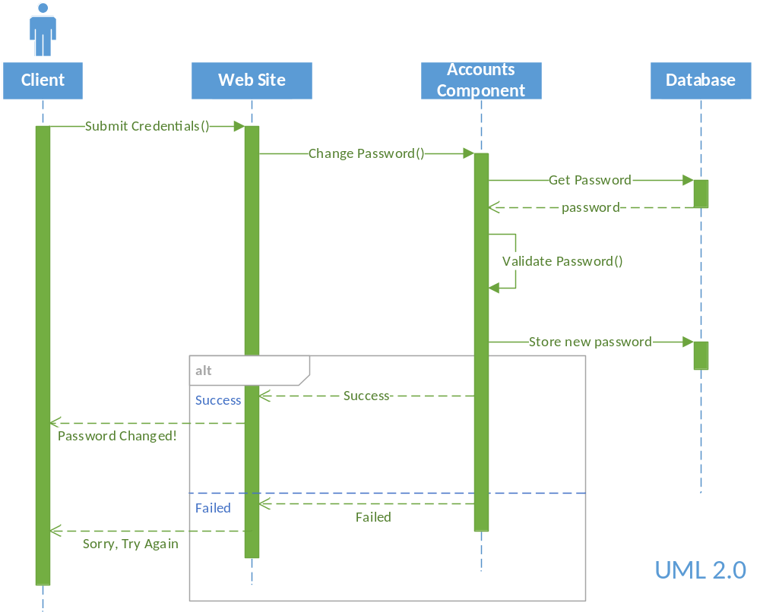

Domain Analysis
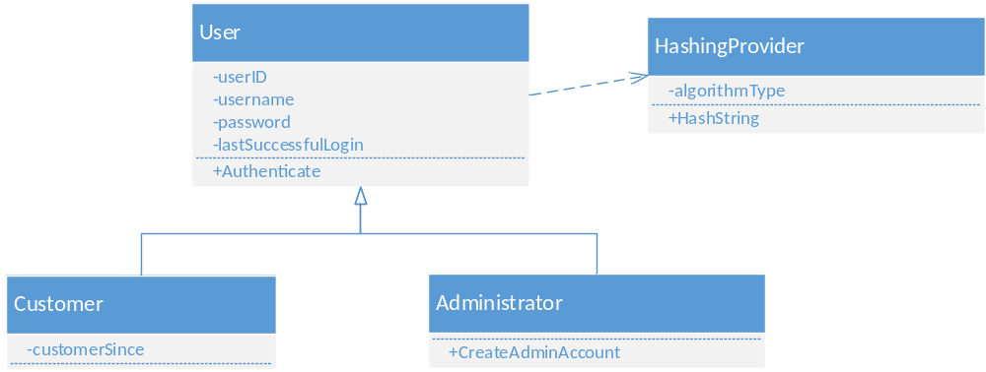
The class diagram above identifies the main entities for the Registration/Authentication module.
The following entities have been identified:
User:
This entity is responsible for authenticating any user and grant access to the system. The User serves as the base class for all different types of clients, such as Customer and Administrator. The User entity has a dependency on the HashingProvider entity. This utility class is used to hash any password required to authenticate the user.
Customer:
This entity represents a single customer and inherits from the User class. It contains a unique attribute of “CustomerSince” which defines how long a customer has been a client of our system.
Administrator:
This entity also inherits all attributes from the User class. It has the ability to create other Administrator type of users. (only administrators can create other admins).
HashingProvider:
This entity is responsible for hashing any string based on the defined algorithm. It is used by the User entity to hash the password strings.

NON-functional requirements
This should describe the non-functional requirements and constraints of the system to be developed. For example, performance, security, usability and maintainability requirements.
For this section of the document, pick two or more non-functional requirements which you consider relevant to your project, and expand on them. If unknown, do a quick research online of which concrete examples can be applied to each non-functional requirement and relate to your project.

Sample Non-functional Requirements
Reliability
This should specify the factors required to establish the required reliability of the software system at time of delivery.

Availability
This should specify the factors required to guarantee a defined availability level for the entire system such as checkpoint, recovery, and restart.

Security
This should specify the factors that protect the software from accidental or malicious access, use, modification, destruction, or disclosure. Specific requirements in this area could include the need to:
- Utilize certain crypto-graphical techniques;
- Keep specific log or history data sets;
- Assign certain functions to different modules;
- Restrict communications between some areas of the program;
- Check data integrity for critical variables.

Maintainability
This should specify attributes of software that relate to the ease of maintenance of the software itself. There may be some requirement for certain modularity, interfaces, complexity, etc. Requirements should not be placed here just because they are thought to be good design practices.

Portability
This should specify attributes of software that relate to the ease of porting the software to other host machines and/or operating systems. This may include the following:
a) Percentage of components with host-dependent code;
b) Percentage of code that is host dependent;
c) Use of a proven portable language;
d) Use of a particular compiler or language subset;
e) Use of a particular operating system

Appendix
These should provide detailed, specific information that is related to the application being developed; for example, hardware and database descriptions. Hardware requirements define the minimal and optimal configurations for the system. Database requirements define the logical organization of the data used by the system and the relationships between data.
Attached documentation. i.e., hardware description, database system description, business rules and policies.

Index
Identify key words and list them with the corresponding page or section

